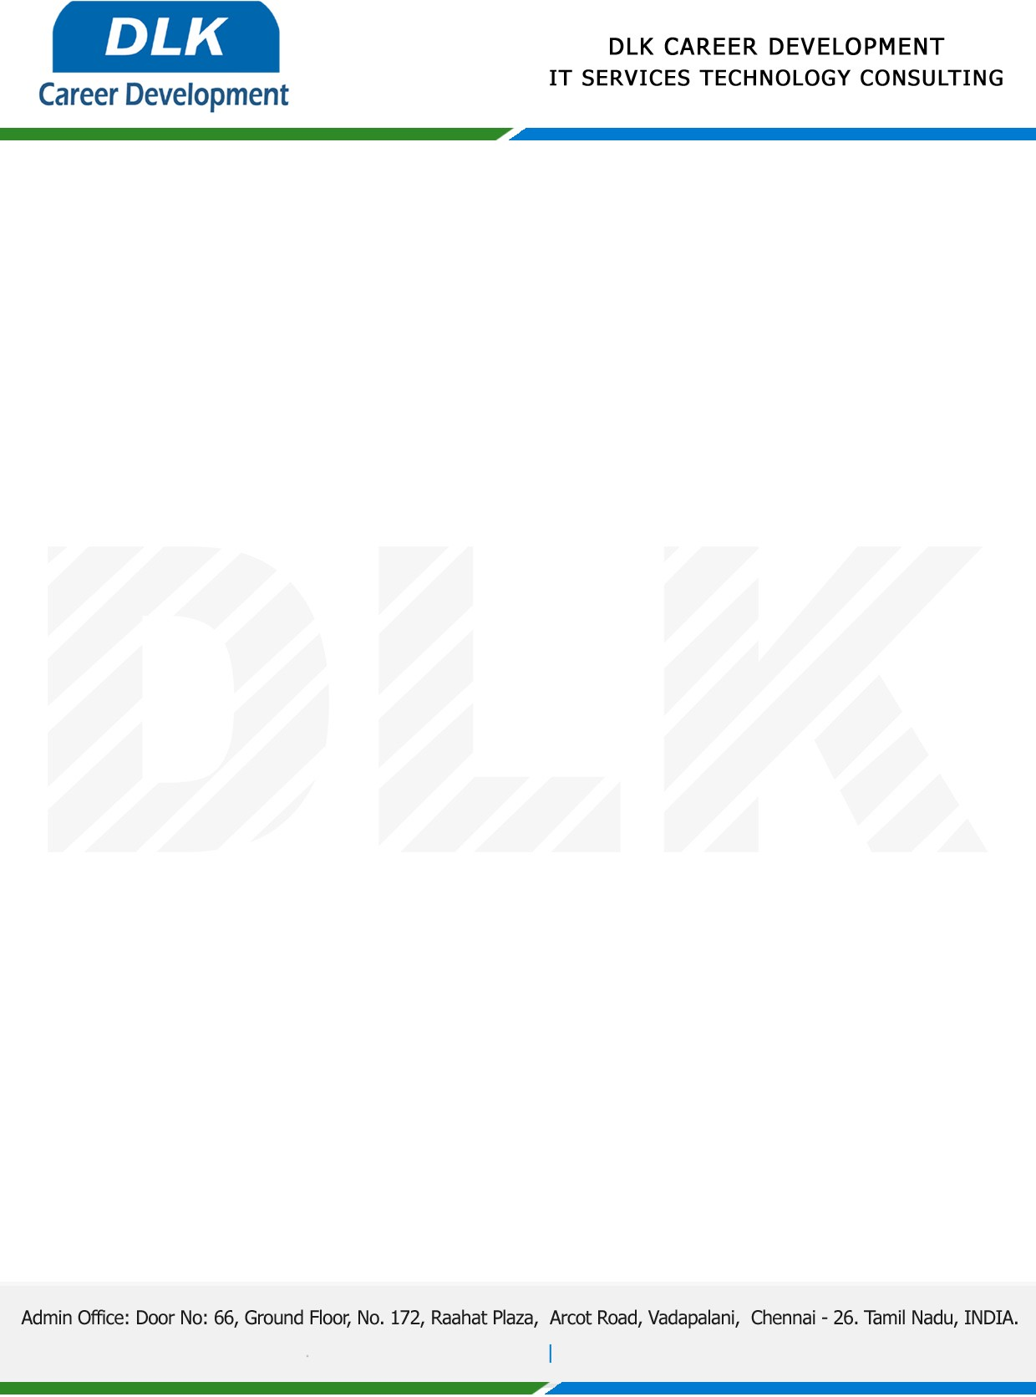

Date: 03 / January/ 2023

**To**

Department of MCA ( [Computer Application),](https://www.cseindia.org/)

Head of Department,

Vels University , Chennai - 600117.

**Sub: Letter of Project Acceptance**

This is to certify that **MR NANTHA KUMAR J (REG NO: 21304249)** final year student of has accepted the Project Work duration from **January 2023 to May 2023** under the domain **“Java”.** During the Project, all information and data collected from you should be kept confidential.

**Topic:** A Verifiable and fair attribute - based proxy re-encryption Scheme for data sharing in clouds.

We appreciate your interest in **DLK CAREER DEVELOPMENT**

